Agent_Specification.md

Student OS Agent Specification
This document defines the complete behavioral specification for the three-agent Student OS architecture.
The specification is implementation-ready and aligned with:
- Student_OS_Final_Spec.md
- Repository_Structure_Spec.md
- Data_Model_Spec.md
- Memory_Architecture.md
- Skills_Architecture.md
- Security_Architecture.md
- Scholarship_Dataset_Spec.md

1. Orchestrator Agent

1.1 Agent Overview
Agent Name
Orchestrator Agent
Purpose
Central coordinator responsible for receiving requests, validating data, routing tasks to specialized agents, aggregating outputs, updating memory, and generating student-facing responses.
Primary Responsibilities
- Receive all user requests
- Load memory
- Validate inputs
- Determine required workflow
- Invoke Academic Risk Agent
- Invoke Opportunity Scout Agent
- Generate Weekly Briefings
- Manage memory updates
- Log activities
- Generate alerts
Non-Responsibilities
- Direct GPA risk analysis
- Scholarship scoring
- Scholarship eligibility calculations
- Dataset maintenance
- Security policy definition

1.2 Inputs
Name | Source | Type | Required | Validation
User Request | User | String | Yes | Non-empty
Student Profile | student_profile.json | StudentProfile | Yes | Schema validation
Activity History | activity_log.json | ActivityLog[] | Optional | Schema validation
Alert History | alert_history.json | Alert[] | Optional | Schema validation
Academic Risk Result | Academic Risk Agent | RiskAssessment | Optional | Schema validation
Scholarship Results | Opportunity Scout Agent | ScholarshipMatch[] | Optional | Schema validation

1.3 Outputs
Workflow Decision
Type:
WorkflowType
Example:
RUN_RISK_ASSESSMENT

Weekly Briefing
Type:
WeeklyBriefing
Example:
{
"summary":"GPA stable",
"alerts":[...],
"scholarships":[...]
}

Memory Update Request
Type:
MemoryUpdate
Example:
{
"field":"current_gpa",
"value":3.75
}

1.4 Memory Access
Read Permissions
- student_profile.json
- activity_log.json
- alert_history.json
Write Permissions
- student_profile.json
- activity_log.json
- alert_history.json
Update Rules
- Validate schema
- Validate security policy
- Create update proposal
- Apply update
- Log update event
- Reject invalid updates

1.5 Skills Used
Weekly Briefing Generation
Purpose
Generate student summary.
Input Contract
StudentProfile
RiskAssessment
ScholarshipMatches
AlertHistory
Output Contract
WeeklyBriefing
Invocation Conditions
- Scheduled briefing
- User requests summary

1.6 Trigger Conditions
Automatic Triggers
- Profile update
- New grade entered
- New semester data
User-Initiated Triggers
- "Assess my GPA"
- "Find scholarships"
- "Generate weekly report"
Scheduled Triggers
- Weekly briefing schedule

1.7 Decision Logic
LOAD student_profile

IF profile invalid
RETURN error

DETERMINE request type

IF request = GPA assessment
CALL Academic Risk Agent

IF request = scholarship search
CALL Opportunity Scout Agent

IF request = weekly briefing
CALL Academic Risk Agent
CALL Opportunity Scout Agent
GENERATE briefing

VALIDATE outputs

UPDATE memory

RETURN response

1.8 Security Boundaries
Allowed Operations
- Read memory
- Write approved memory
- Invoke agents
- Log events
Forbidden Operations
- External database access
- Direct scholarship scoring
- Direct GPA calculations
Trust Boundaries
- User input boundary
- Agent response boundary
- Memory boundary
Memory Restrictions
Only approved schema updates allowed.

1.9 Error Handling
Missing Profile
Detection:
Profile file missing
Response:
Request profile creation
Logging:
ERROR_PROFILE_MISSING

Invalid GPA
Detection:
GPA outside allowed range
Response:
Reject request
Logging:
ERROR_INVALID_GPA

Corrupted Memory
Detection:
Schema validation failure
Response:
Load backup version
Logging:
ERROR_MEMORY_CORRUPTED

Empty Dataset
Detection:
No scholarship records
Response:
Return empty results
Logging:
WARNING_EMPTY_DATASET

Invalid Agent Output
Detection:
Schema validation failure
Response:
Discard output
Logging:
ERROR_AGENT_OUTPUT

1.10 Example Workflows
Workflow A — Successful Execution
Input:
Assess GPA
Processing:
Load profile
Call Academic Risk Agent
Receive assessment
Output:
Risk Score = 0.18
Status = Low Risk

Workflow B — Error Scenario
Input:
Assess GPA
Processing:
Profile missing
Output:
Create profile first

Workflow C — Memory Update
Input:
New GPA submitted
Processing:
Validate GPA
Update profile
Log activity
Output:
Profile updated

2. Academic Risk Agent

2.1 Agent Overview
Agent Name
Academic Risk Agent
Purpose
Evaluate academic performance and identify students at risk.
Primary Responsibilities
- GPA analysis
- Academic trend analysis
- Risk classification
- Risk alert generation
Non-Responsibilities
- Scholarship matching
- Memory management
- Weekly report generation

2.2 Inputs
Name | Source | Type | Required | Validation
Student Profile | Memory | StudentProfile | Yes | Schema validation
GPA | Profile | Float | Yes | Valid range
Academic History | Activity Log | ActivityLog[] | Optional | Schema validation

2.3 Outputs
Risk Assessment
Type:
RiskAssessment
Example:
{
"risk_score":0.82,
"risk_level":"HIGH"
}

Alert
Type:
Alert
Example:
{
"type":"ACADEMIC_RISK"
}

2.4 Memory Access
Read Permissions
- student_profile.json
- activity_log.json
Write Permissions
None
Update Rules
Memory updates proposed to Orchestrator only.

2.5 Skills Used
GPA Risk Assessment
Purpose
Determine academic risk level.
Input Contract
StudentProfile
Output Contract
RiskAssessment
Invocation Conditions
- GPA update
- User request
- Weekly briefing

2.6 Trigger Conditions
Automatic
- GPA changes
User
- Academic assessment request
Scheduled
- Weekly briefing pipeline

2.7 Decision Logic
LOAD profile

EXTRACT GPA

IF GPA >= 3.5
LOW_RISK

ELSE IF GPA >= 2.5
MEDIUM_RISK

ELSE
HIGH_RISK

GENERATE assessment

IF HIGH_RISK
GENERATE alert

RETURN result

2.8 Security Boundaries
Allowed
- Read profile
- Read activities
Forbidden
- Write memory
- Access scholarship data
- Modify alerts
Trust Boundary
Output validated by Orchestrator.
Memory Restrictions
Read-only access.

2.9 Error Handling
Missing Profile
Return:
ASSESSMENT_FAILED
Log:
PROFILE_NOT_FOUND

Invalid GPA
Return:
INVALID_INPUT
Log:
INVALID_GPA

Corrupted Memory
Return:
DATA_ERROR
Log:
MEMORY_CORRUPTED

Invalid Output
Return:
ASSESSMENT_REJECTED
Log:
OUTPUT_VALIDATION_FAILED

2.10 Example Workflows
Workflow A
Input:
GPA = 3.8
Output:
LOW_RISK

Workflow B
Input:
GPA = -1
Output:
INVALID_INPUT

Workflow C
Input:
New GPA
Processing:
Assess risk
Propose alert
Output:
Risk Assessment

3. Opportunity Scout Agent

3.1 Agent Overview
Agent Name
Opportunity Scout Agent
Purpose
Match students with scholarship opportunities.
Primary Responsibilities
- Scholarship filtering
- Eligibility validation
- Scholarship ranking
- Opportunity recommendations
Non-Responsibilities
- GPA risk assessment
- Memory updates
- Weekly report generation

3.2 Inputs
Name | Source | Type | Required | Validation
Student Profile | Memory | StudentProfile | Yes | Schema validation
Scholarship Dataset | scholarships.json | Scholarship[] | Yes | Dataset validation

3.3 Outputs
Scholarship Matches
Type:
ScholarshipMatch[]
Example:
[
{
"scholarship_id":"SCH001",
"match_score":92
}
]

Opportunity Alert
Type:
Alert
Example:
{
"type":"SCHOLARSHIP_MATCH"
}

3.4 Memory Access
Read Permissions
- student_profile.json
Write Permissions
None
Update Rules
Propose updates through Orchestrator.

3.5 Skills Used
Scholarship Matching
Purpose
Identify best scholarship opportunities.
Input Contract
StudentProfile
ScholarshipDataset
Output Contract
ScholarshipMatch[]
Invocation Conditions
- User request
- Weekly briefing
- Profile update

3.6 Trigger Conditions
Automatic
- Profile changes
User
- Scholarship request
Scheduled
- Weekly briefing workflow

3.7 Decision Logic
LOAD profile

LOAD scholarship dataset

FOR EACH scholarship

CHECK eligibility

IF eligible

CALCULATE match score

ADD to candidate list

SORT by score

RETURN top matches

3.8 Security Boundaries
Allowed
- Read profile
- Read scholarship dataset
Forbidden
- Memory modification
- GPA assessment
- Alert modification
Trust Boundary
Output validated by Orchestrator.
Memory Restrictions
Read-only access.

3.9 Error Handling
Missing Profile
Return:
MATCHING_FAILED
Log:
PROFILE_NOT_FOUND

Empty Dataset
Return:
NO_MATCHES
Log:
EMPTY_DATASET

Corrupted Dataset
Return:
DATA_ERROR
Log:
DATASET_CORRUPTED

Invalid Output
Return:
MATCHING_REJECTED
Log:
OUTPUT_VALIDATION_FAILED

3.10 Example Workflows
Workflow A
Input:
GPA = 3.8
Major = CS
Output:
Top 5 scholarships

Workflow B
Input:
Dataset empty
Output:
No opportunities available

Workflow C
Input:
Profile updated
Processing:
Re-run matching
Output:
Updated recommendations

4. Agent Interaction Model

Request Format
Orchestrator → Specialized Agent
{
"request_id":"UUID",
"agent":"AcademicRiskAgent",
"payload":{...}
}

Response Format
Agent → Orchestrator
{
"request_id":"UUID",
"status":"SUCCESS",
"result":{...}
}

Failure Handling
IF timeout
RETRY ONCE

IF validation failure
REJECT RESPONSE

IF repeated failure
LOG ERROR
RETURN SAFE RESPONSE

5. Sequence Diagrams

Risk Assessment Flow
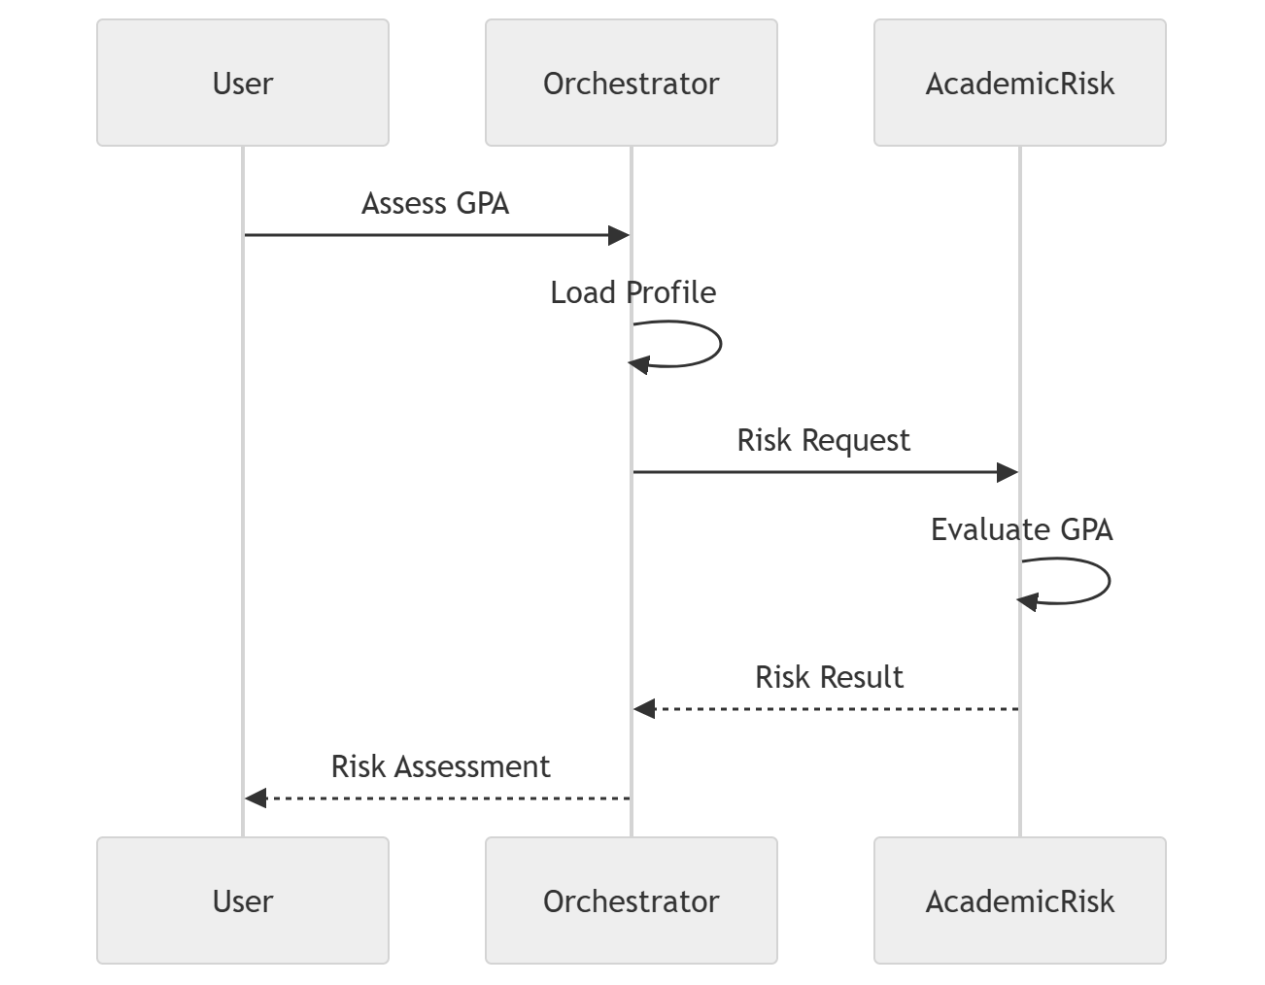

Scholarship Matching Flow
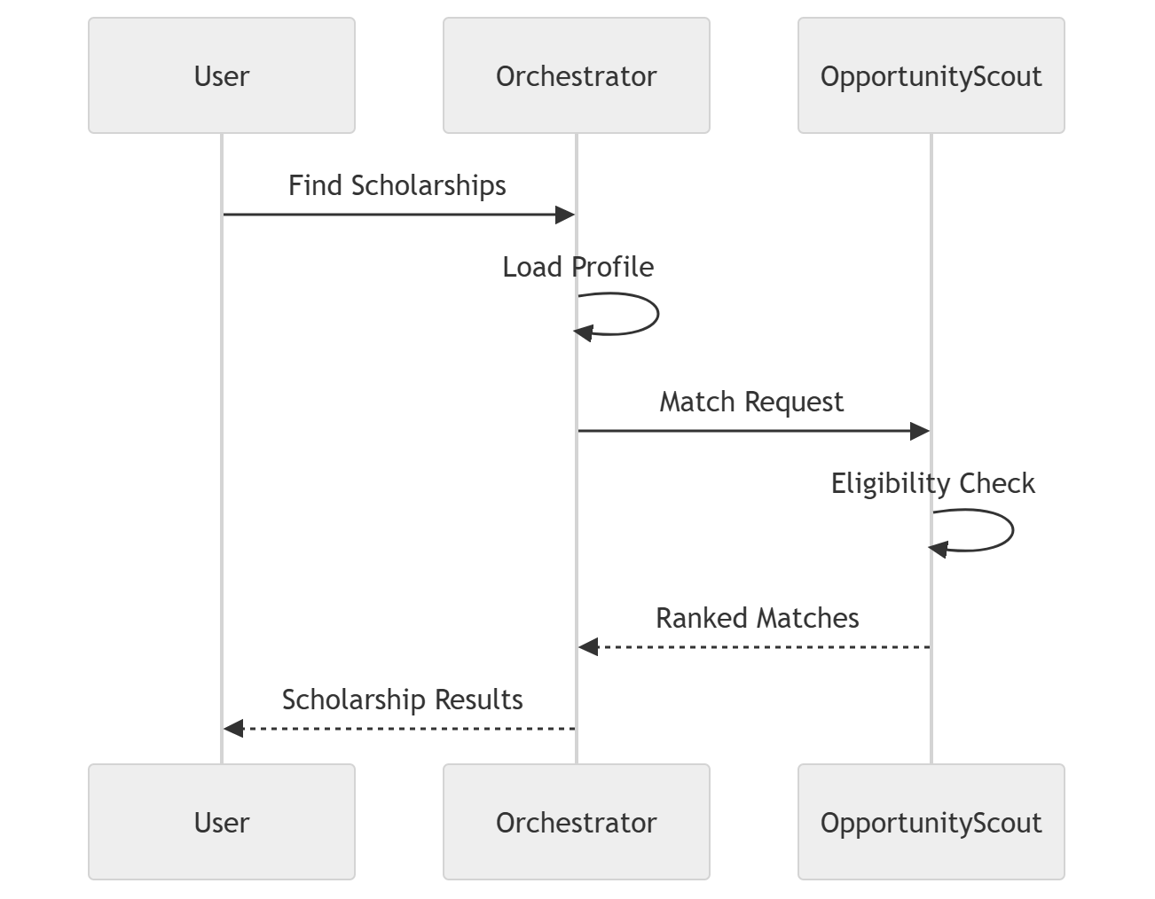

Weekly Briefing Generation Flow
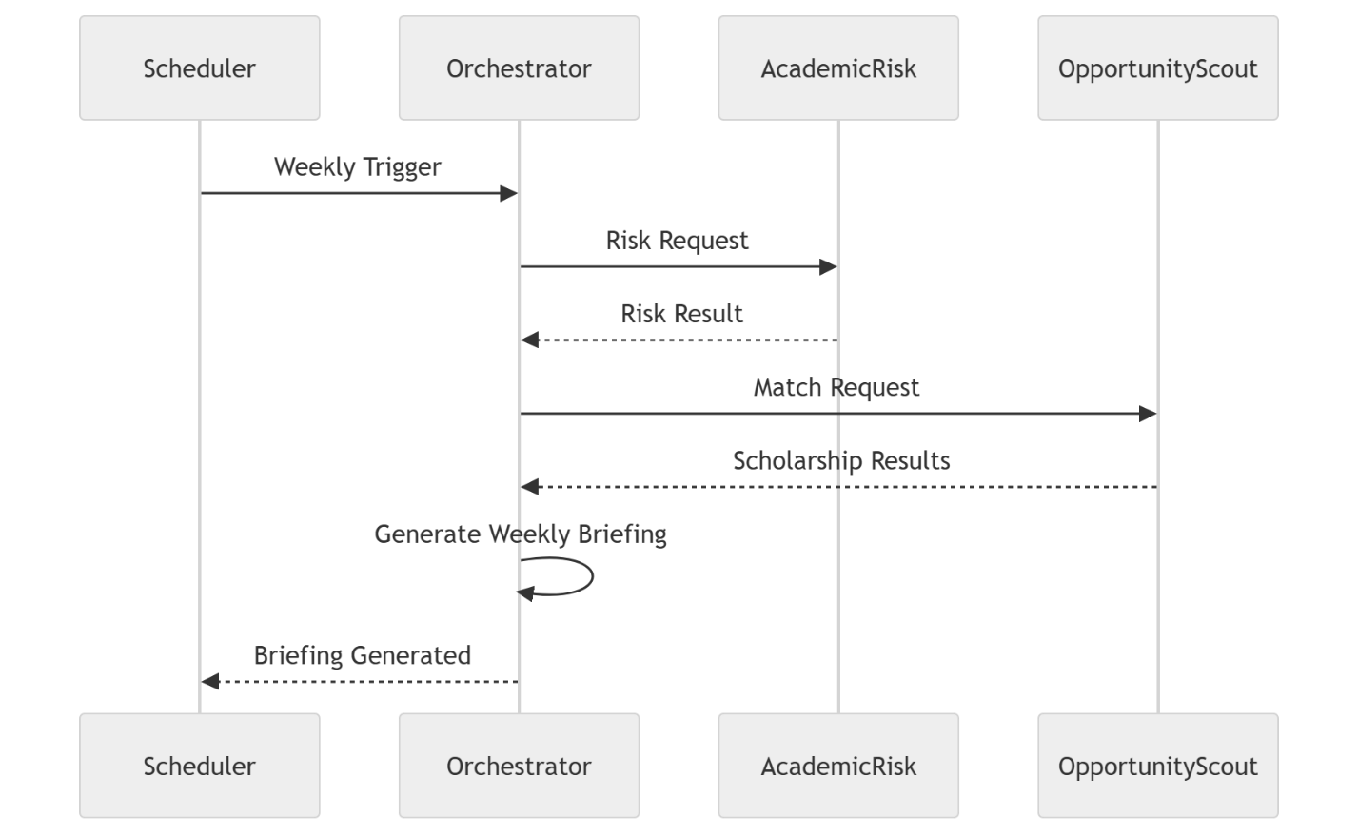
End of Agent_Specification.md

